**UML DIAGRAMS**

# **CLASS DIAGRAM**

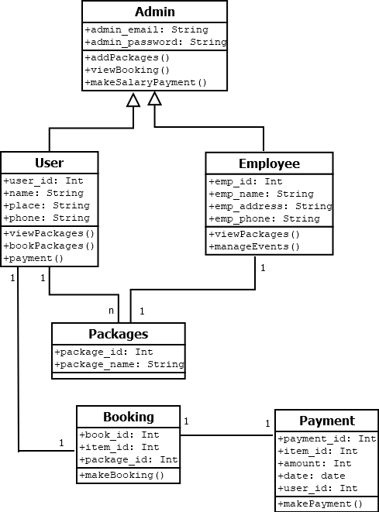

# **OBJECT DIAGRAM**

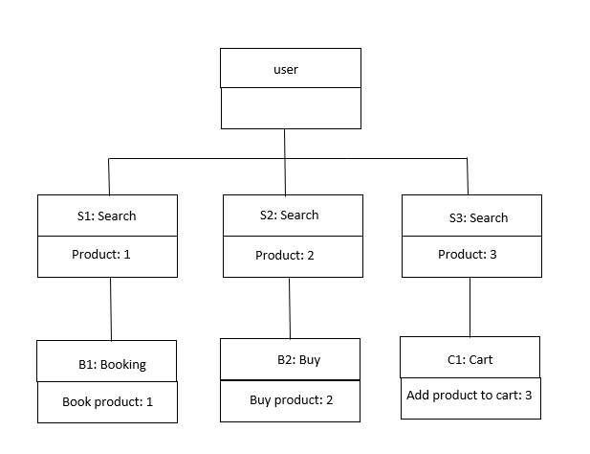

**DEPLOYMENT DIAGRAM**

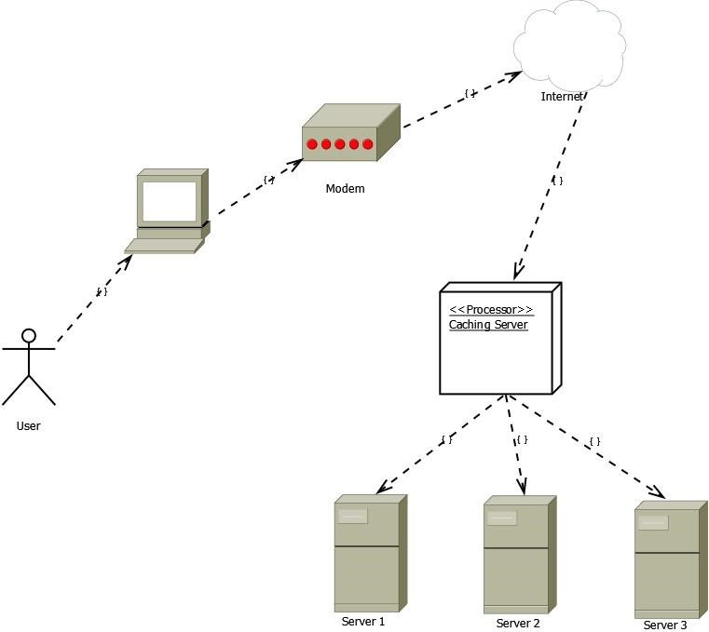

**BEHAVIOUR DIAGRAM**

**USECASE:**

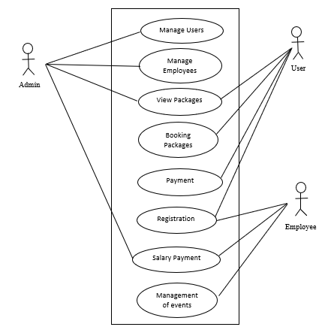

# **SEQUENCE DIAGRAM**

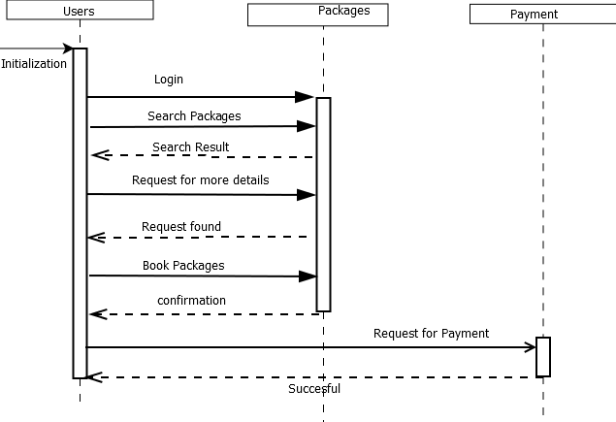

# **COLLABORATION DIAGRAM**

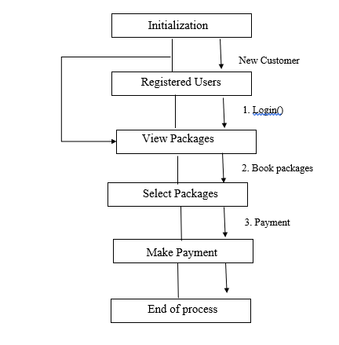

# **STATE CHART DIAGRAM**

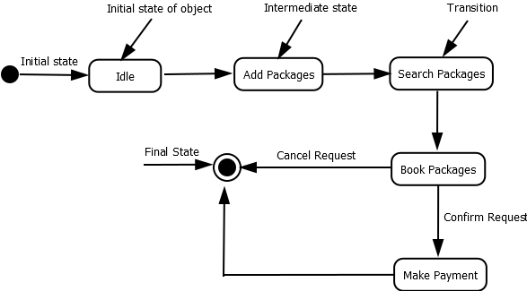

# **ACTIVITY DIAGRAM**

